SIMULATION TASK

Experiment
35 Plant G(s) = 1/(0.005s + 0.5) (grid inductor model). PI controller C(s) = Kp + Ki/s. In MATLAB, set Kp=5, Ki=100. Form closed-loop using feedback(series(C,G),1). Plot Bode of open loop and step response of closed loop. Use margin() to print gain and phase margins. Verify steady-state error to step input equals zero (due to integral action).
Program:
clc;
clear;
close all;
%% Plant
% G(s) = 1/(0.005s + 0.5)
G = tf(1, [0.005 0.5]);
%% PI Controller
% C(s) = Kp + Ki/s
Kp = 5;
Ki = 100;
C = pid(Kp, Ki);
%% Open-loop transfer function
L = series(C, G);
%% Closed-loop transfer function
T = feedback(L, 1);
%% Display transfer functions
disp('Plant G(s):');
G
disp('PI Controller C(s):');
C
disp('Open-loop transfer function L(s):');
L
disp('Closed-loop transfer function T(s):');
T
%% Bode plot of open-loop system
figure;
bode(L);
grid on;
title('Bode Plot of Open-Loop System');
%% Gain Margin and Phase Margin
[Gm, Pm, Wcg, Wcp] = margin(L);
fprintf('\n--- Stability Margins ---\n');
if isinf(Gm)
fprintf('Gain Margin = Inf dB\n');
else
fprintf('Gain Margin = %.2f dB\n', 20*log10(Gm));
end
fprintf('Phase Margin = %.2f degrees\n', Pm);
fprintf('Gain Crossover Frequency = %.2f rad/s\n', Wcp);
fprintf('Phase Crossover Frequency = %.2f rad/s\n', Wcg);
%% Step response of closed-loop system
figure;
step(T);
grid on;
title('Closed-Loop Step Response');
xlabel('Time (s)');
ylabel('Output');
%% Steady-state error for unit-step input
ess = abs(1 - dcgain(T));
fprintf('\n--- Steady-State Error ---\n');
fprintf('Steady-state error = %.6f\n', ess);

if ess < 1e-6
fprintf('Steady-state error is approximately ZERO.\n');
fprintf('This is due to the integral action of the PI controller.\n');
else
fprintf('Steady-state error is NOT zero.\n');
end

Output Waveform
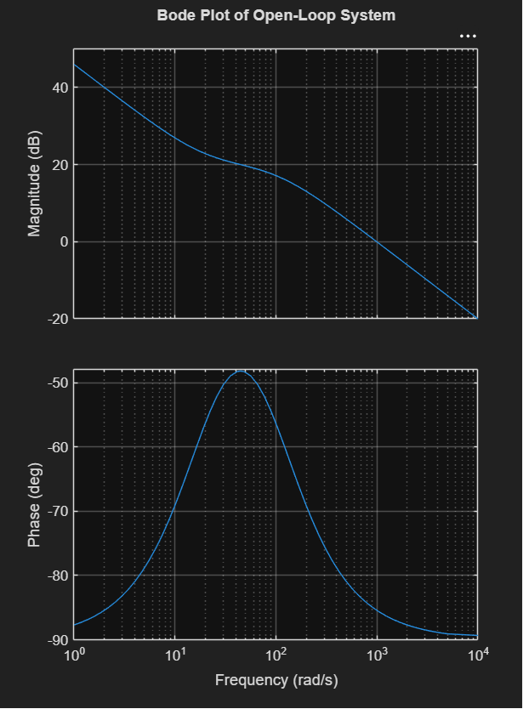
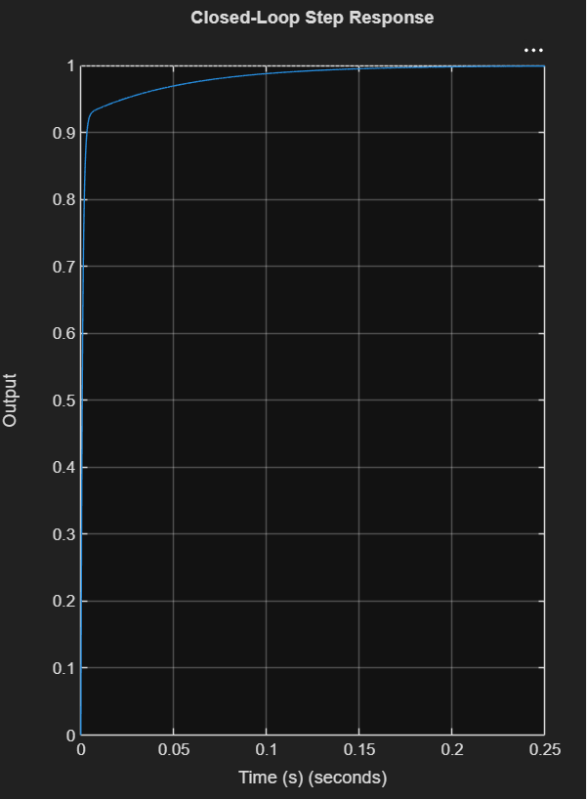
Result
The MATLAB simulation of the grid inductor model with PI controller was successfully performed using:
- Plant:
- PI Controller:
The open-loop Bode plot was obtained and the gain margin and phase margin were evaluated using margin(). The closed-loop step response showed that the output reaches the unit reference value.
Experiment
Characteristic polynomial of a suspension controller: s^4 + 5s^3 + 8s^2 + 6s + K. In Scilab, define the polynomial using poly(). Use a loop to test stability (all roots have negative real parts) for K = 0:0.5:20 using roots(). Plot real parts of all roots vs K. Mark the range of K for BIBO stability
Program:
clc;
clear;
close all;
% K values
K = 0:0.5:20;
stable = zeros(size(K));
% Store real parts of roots
R = zeros(length(K),4);
% Test stability
for i = 1:length(K)
p = [1 5 8 6 K(i)];
r = roots(p);
R(i,:) = real(r);
if all(real(r) < 0)
stable(i) = 1;
end
end
% Plot real parts of all roots
figure;
plot(K,R,'LineWidth',1.5);
yline(0,'k--');
grid on;
xlabel('K');
ylabel('Real Parts of Roots');
title('Root Real Parts vs K');
legend('Root 1','Root 2','Root 3','Root 4','Location','best');
% Display stable K values
fprintf('Stable K values:\n');
disp(K(stable == 1));
fprintf('BIBO stable range: K = %.1f to %.1f\n', ...
min(K(stable==1)), max(K(stable==1)));

Output Waveform
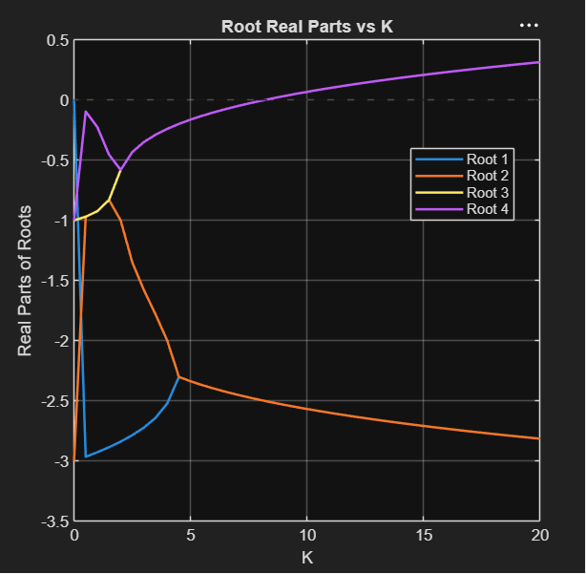
Result
The stability analysis of the suspension controller characteristic polynomial
was successfully performed in MATLAB for .
- Stable range within the tested values:
- At , one root lies at the origin , so the system is not BIBO stable.
- For all tested values to , all roots have negative real parts.
- The plot of root real parts versus confirms that the poles remain in the left-half -plane

